ABC Education Series **FRICTION!**

Use the link below to view the video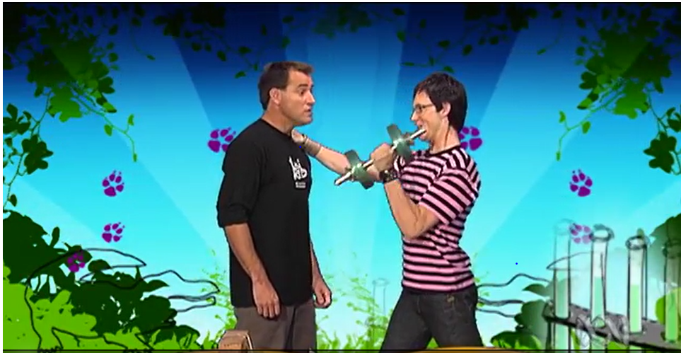

<https://education.abc.net.au/home#!/media/106564/friction-between-paper-experiment>

**Before you View**

What is friction? Sometimes it is our friend and sometimes it makes things difficult.  
Can you think of any everyday examples where there is friction? Think about riding a bike; is there an example on a bike where friction is our friend? What about how friction makes cycling hard?

**As you View**

What happens when Elliot tries to pull two sheets of paper apart?  
Watch as Ruben prepares the two books to test friction between the pages. What happens when Elliot tries to pull the books apart?  
Why are the books tied to a brick?  
Ruben say the experiment shows the strength of something. What is it?

**After you View**

Now repeat the experiment from the clip. Don't forget to set it up carefully by preparing the books as shown by Ruben. Try it out on your parents or friends and surprise them with your science knowledge!  
Take digital photographs and create your own science report.

**Next**

Find out more about friction and how it affects our everyday life. Advertise a new range of sports shoe or bicycle tyre. Persuade consumers to buy the product based on how it performs (overcomes or makes use of) friction.