Year 4 Science

May the Force be with you!

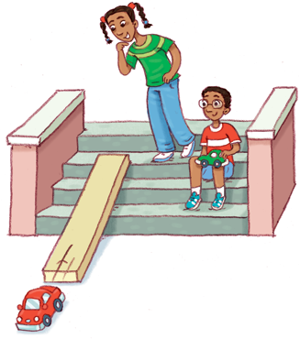

Jingeri Jimbelung

This workbook has been designed to be used in conjunction with the year 4 Science ClassNotebook.

This term we are exploring our Physical Science unit – May the Force be with you.

We will be developing your understanding of forces from your base knowledge of push (away) and pull (towards) forces to looking at contact and distant forces (eg friction and gravity).

We will be using force arrow diagrams to represent our understanding, conducting fair tests and having a lot of fun along the way.

To begin with let’s look at our K-W I can chart – what do you already know about forces (what can you remember from the Push and Pull unit?), what do you want to know? Make sure you also have a read of the ‘I can’ statements so you know where we’re headed.

**K-W I Can**

|  |  |
| --- | --- |
| *What I know* | *What I want to know* |
|  |  |

*I can:*

* Describe how forces can be exerted by one object on another;
* Explain the difference between a contact force and a distance force;
* Compare and contrast the effect of friction on different surfaces;
* Make predictions, compare results with my predictions and suggest possible reasons for my findings.
* Gather information/data and identify patterns and relationships in it;
* Communicate my ideas and findings using diagrams and simple reports.

*Vocabulary*

|  |  |  |  |
| --- | --- | --- | --- |
| Force | *Contact* | *Distant* | *Distance* |
| Stationary | *Friction* | *Gravity* | *Air resistance* |
| Motion | *Magnitude* | *Mass* | *Direction* |

11 Forceful Facts to Remember

How are objects moved by forces? Watch the videos in our Science ClassNotebook and fill in the missing words using the words below.

|  |  |  |  |  |  |  |  |
| --- | --- | --- | --- | --- | --- | --- | --- |
| energy | away | size | go | pairs | direction | towards | move |
| bigger | opposite | speed | distance | balanced | stop | direction | size |

|  |  |
| --- | --- |
| 1 | Objects can only m___________ if they are forced. |
| 2 | Forces act on objects in p__________. |
| 3 | The 2 forces (pulling down and pushing up) acting on stationary objects are b_________________. |
| 4 | Balanced forces are equal in s________ but act in o_____________ directions. |
| 5 | Unbalanced forces make objects g__, s______, change s________ or change d_______________. |
| 6 | The bigger the object the b___________ the force that is needed to start or stop it moving. |
| 7 | A push moves an object a_________ from the force. |
| 8 | A pull moves an object t_____________ the force. |
| 9 | Contact forces touch objects and pass e_______________ to them. |
| 10 | Gravity pulls on objects from a d________________. |
| 11 | Forces are shown on diagrams using arrows that show the d_____________ and s_________ of the force. |

Label the diagram below to show what force is being used and the direction of each force.

[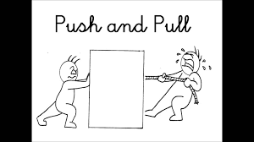](https://www.google.com/url?sa=i&rct=j&q=&esrc=s&source=images&cd=&cad=rja&uact=8&ved=2ahUKEwi9tqmQl9bhAhXOfSsKHTdkD0wQjRx6BAgBEAU&url=https://dumielauxepices.net/wallpaper-3233023&psig=AOvVaw2h_4x8uODai6Exo0f6ory_&ust=1555557746981797)

[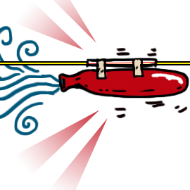](https://www.google.com/url?sa=i&rct=j&q=&esrc=s&source=images&cd=&cad=rja&uact=8&ved=2ahUKEwipwsL-pdbhAhWHbn0KHT0cARYQjRx6BAgBEAU&url=https://sciencebob.com/make-a-balloon-rocket/&psig=AOvVaw2b9Jvay6XOJWoWLl-BVlxf&ust=1555561836282739)

**Balloon Rockets**

**Scientific Investigation**

|  |  |  |  |
| --- | --- | --- | --- |
| Plan |  | Fair Test | [Image result for science cows moo softly](https://www.google.com/imgres?imgurl=https://i.dlpng.com/static/png/1288426_thumb.png&imgrefurl=https://dlpng.com/?pageNo%3D19392&docid=yqzZLmS4EYBnuM&tbnid=eFzofvatrxjIlM:&vet=10ahUKEwjn1eGLuJDhAhUjguYKHa8SAFAQMwhrKCEwIQ..i&w=400&h=322&itg=1&bih=607&biw=1280&q=science%20cows%20moo%20softly&ved=0ahUKEwjn1eGLuJDhAhUjguYKHa8SAFAQMwhrKCEwIQ&iact=mrc&uact=8) |
| **C**ows  **M**oo  **S**oftly | Change one thing only  Measure or observe  Keep everything else the Same | *Independent Variable*  *Dependent Variable*  *Control Variable* |

|  |  |  |
| --- | --- | --- |
| **Explore** | | |
| *Aim/investigation Question*  What effect does different sized forces have on the motion of objects? (What effect will different sized balloons have on the distance travelled by a straw along a string?) | | |
|  | | |
| **Equipment** | | |
|  |  |  |
| Balloon (provided) | Straw (provided) | String (provided) |
| Sticky Tape | Measuring tape | Recording sheet (provided) |

**Method**

1. Tie one end of your string to a chair and thread your straw through the string.
2. 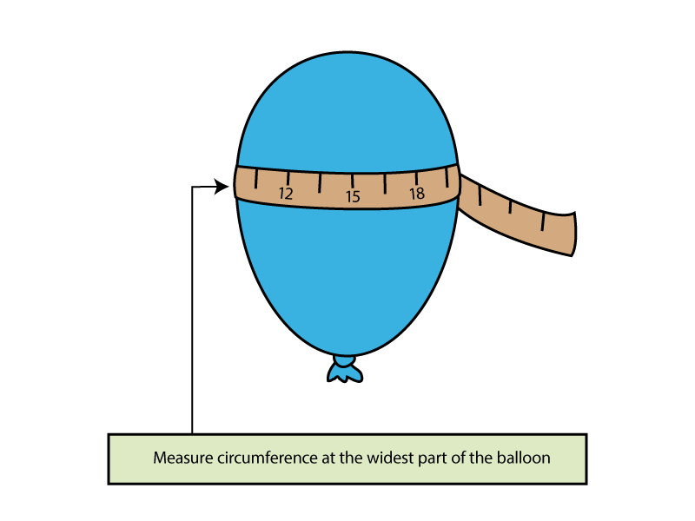Tie the other end of your string to another chair, at the same height and separate the chairs so your string is taunt.
3. Blow up your balloon and twist the end so the air can’t escape – do not tie the end of your balloon. Measure the circumference of your balloon.
4. 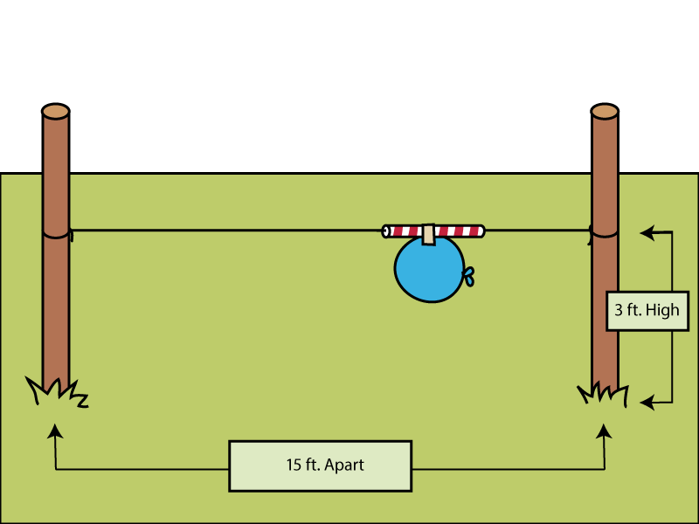Tape your balloon onto your straw so the neck of the balloon is facing away from the direction of travel.
5. Let go of the neck of your balloon and watch it fly. Measure and record the point on the string at which the balloon stopped.

This SciShow Kids link provides a great demonstration and background information if you have online access [**https://www.youtube.com/watch?v=KMX7zgaLC0w**](https://www.youtube.com/watch?v=KMX7zgaLC0w)

*Before you conduct your experiment what do you think will happen?* ***If*** *the balloon has more/less air* ***then****….what do you think will happen?* ***Because****…can you tell me why you think that?*

|  |
| --- |
| Predict |
| If_________________________________________________________________ then______________________________________________________________ because________________________________________________________________________________________________________________________________________________________________________________________________ |

|  |  |  |  |  |
| --- | --- | --- | --- | --- |
| My Results | | | | |
| Balloon Size | Distance straw travelled (cm) | | | Average |
| Very Small - _______ cm round |  |  |  |  |
| Small - _______ cm round |  |  |  |  |
| Medium - _______ cm round |  |  |  |  |
| Large - _______ cm round |  |  |  |  |

Test each size 3 times and work out the average (add distance of each attempt and divide the total by 3).

**Graph you result averages**

My Graph: **_______________________________________________**

|  |  |  |  |  |  |  |  |  |  |  |
| --- | --- | --- | --- | --- | --- | --- | --- | --- | --- | --- |
| Very small balloon |  |  |  |  |  |  |  |  |  |  |
| Small balloon |  |  |  |  |  |  |  |  |  |  |
| Medium balloon |  |  |  |  |  |  |  |  |  |  |
| Large balloon |  |  |  |  |  |  |  |  |  |  |
|  | cm |  |  |  |  |  |  |  |  |  |

Distance travelled (cm)

(Insert appropriate distances in the boxes provided)

|  |
| --- |
| Conclusion – answer your investigation question |
| I claim _____________________________________________________________ My evidence is _______________________________________________________  __________________________________________________________________ This happened because ________________________________________________  __________________________________________________________________ |